

HomeWOrm 5 Python

Python Coding



November 14, 2019

Farah Al-Falahi

Contents

List of Figure 2

Requirement 1 3

Test Case 3

Requirement 04 4

Python Code 4

# List of Figure

Figure 1: Test case 3

Figure 2: Jose 3

Figure 3: Salay 3

Figure 4:: Bill Details 4

Figure 5 :Rachel 4

# Requirement 1

## Test Case

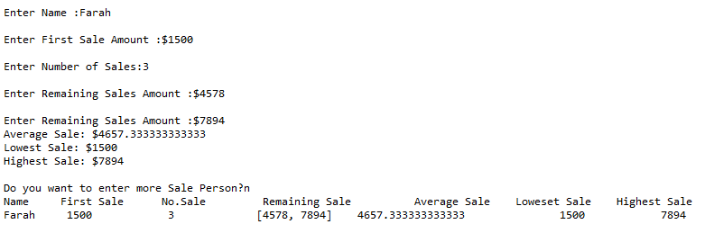

Figure 1: Test case

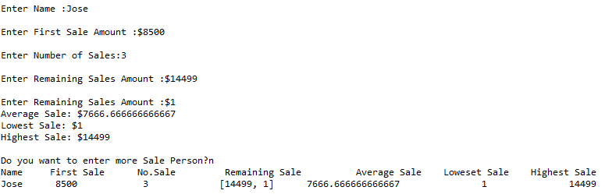

Figure 2: Jose

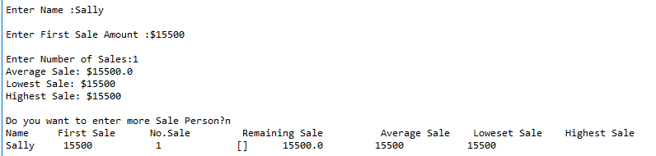

Figure 3: Salay

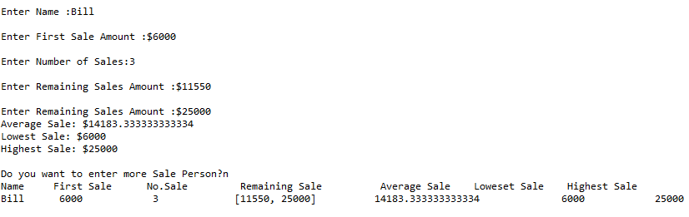

Figure 4:: Bill Details

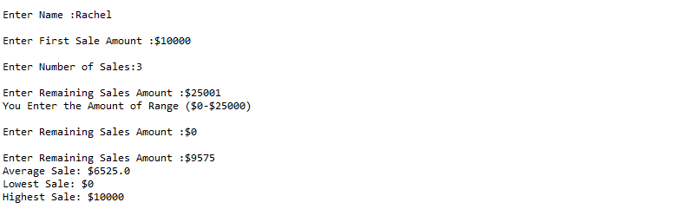

Figure :Rachel

# Requirement 04

## Python Code

def calculateDetail(lst):

print ("Average Sale: $" +str(float(sum(lst)/len(lst))))

print ("Lowest Sale: $"+str(min(lst)))

print ("Highest Sale: $"+str(max(lst)))

allavg.append(float(sum(lst)/len(lst)))

allmin.append(min(lst))

allmax.append(max(lst))

reuse =True

allname=[]

allsale=[]

alldetails=[]

allavg=[]

allmin=[]

allmax=[]

while reuse:

remainList=[]

Name=input('Enter Name :')

allname.append(Name)

FirstSale=int(input("Enter First Sale Amount :$"))

remainList.append(FirstSale)

NoSale=int(input("Enter Number of Sales:"))

allsale.append(NoSale)

for i in range(NoSale-1):

while True:

input_=int(input("Enter Remaining Sales Amount :$"))

if input_<0 or input_>25000:

print ("You Enter the Amount of Range ($0-$25000)")

else:

remainList.append(input_)

break

alldetails.append(remainList)

calculateDetail(remainList)

char=input("Do you want to enter more Sale Person?")

if char=="y":

reuse=True

else:

print ("Name \t First Sale \t No.Sale \t Remaining Sale \t Average Sale \t Loweset Sale \t Highest Sale")

for i in range (len(allname)):

print(allname[i]+"\t "+str(alldetails[i][i]) +"\t\t "+str(allsale[i]) +"\t\t" + str(alldetails[i][1:allsale[i]])+" \t"+str(allavg[i])+ "\t\t"+str(allmin[i])+"\t\t"+ str(allmax[i]) )

break